How to update your version of Visual Studio 2019 to align with CNM’s version and add C++ CLI

- Open the Visual Studio Installer. If you have not updated, update. If you have already updated, click Modify.
- Either way, you will probably get this dialog:

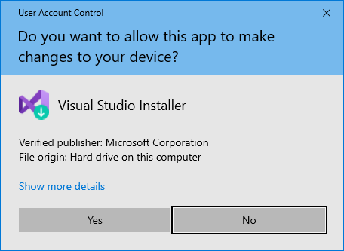

- Select yes. Put the kettle on for a cup of tea.
- You may get this screen (I did.)

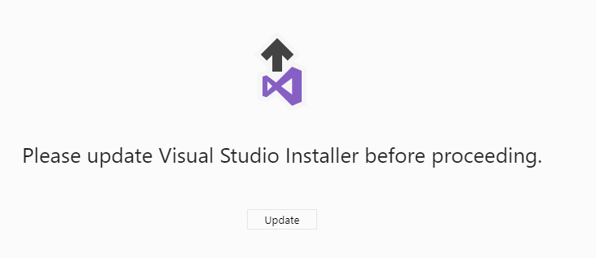

- Select update.
- You will get another dialog:

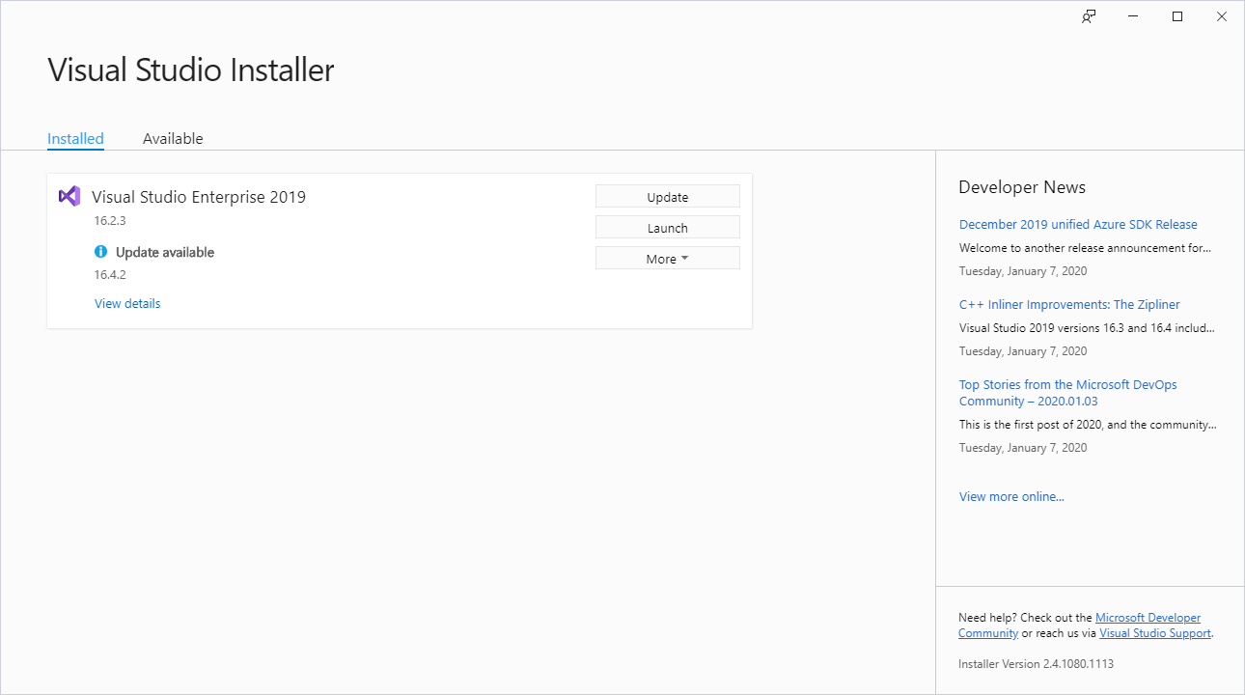

- Select update. Select your tea bag or tea ball and put it in your cup. Add the water. I always select something soothing like chamomile for this process.
- Be patient until the installer has finished updating. Your tea should be ready now.
- I got a window that wants me to Reboot. So I am clicking Restart.
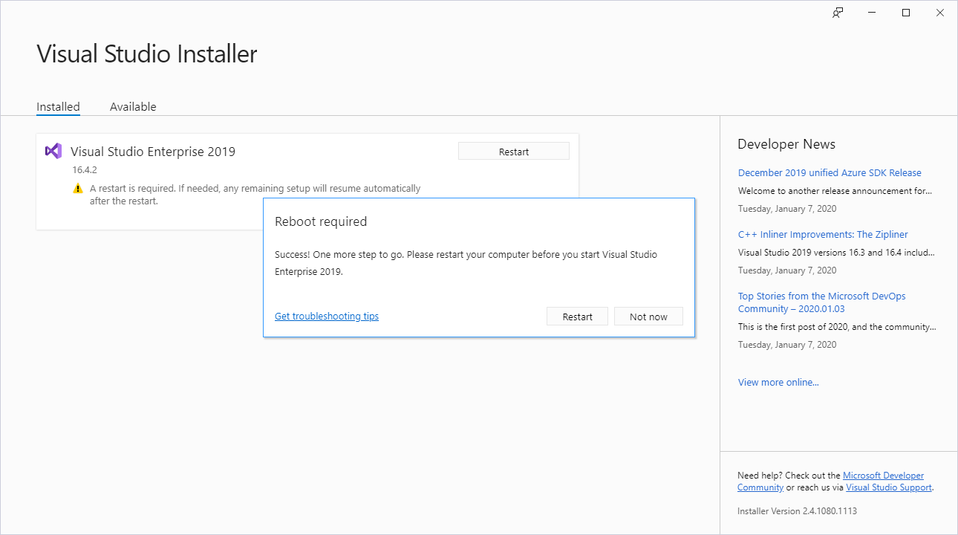

- Restarted. This is what I see:

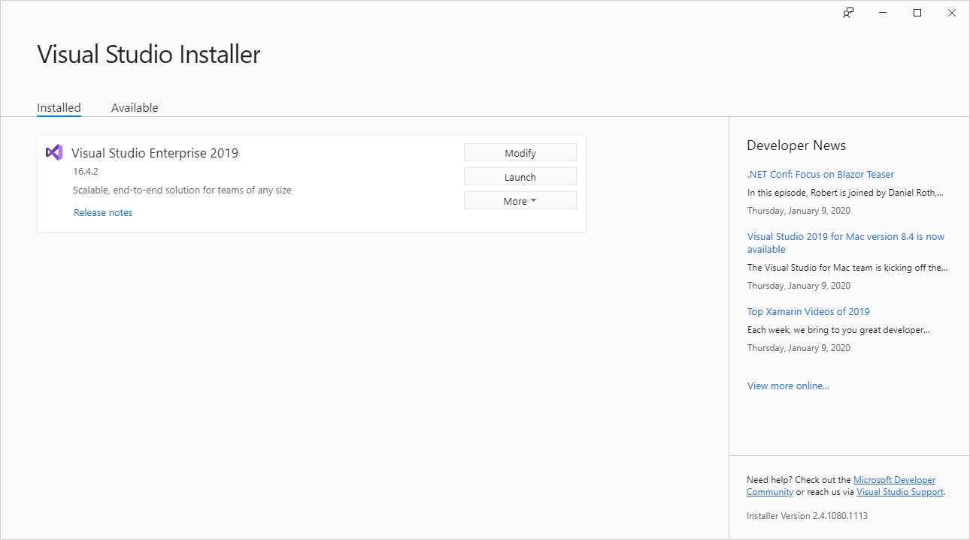
- I need to modify my installation. Click modify. And I am back at the dialog for installation choices. The next steps depend on what you already have installed on your Visual Studio.

- Open up the DeskTop Development with C++ category at the right. You will see that the list under installation details has changed.
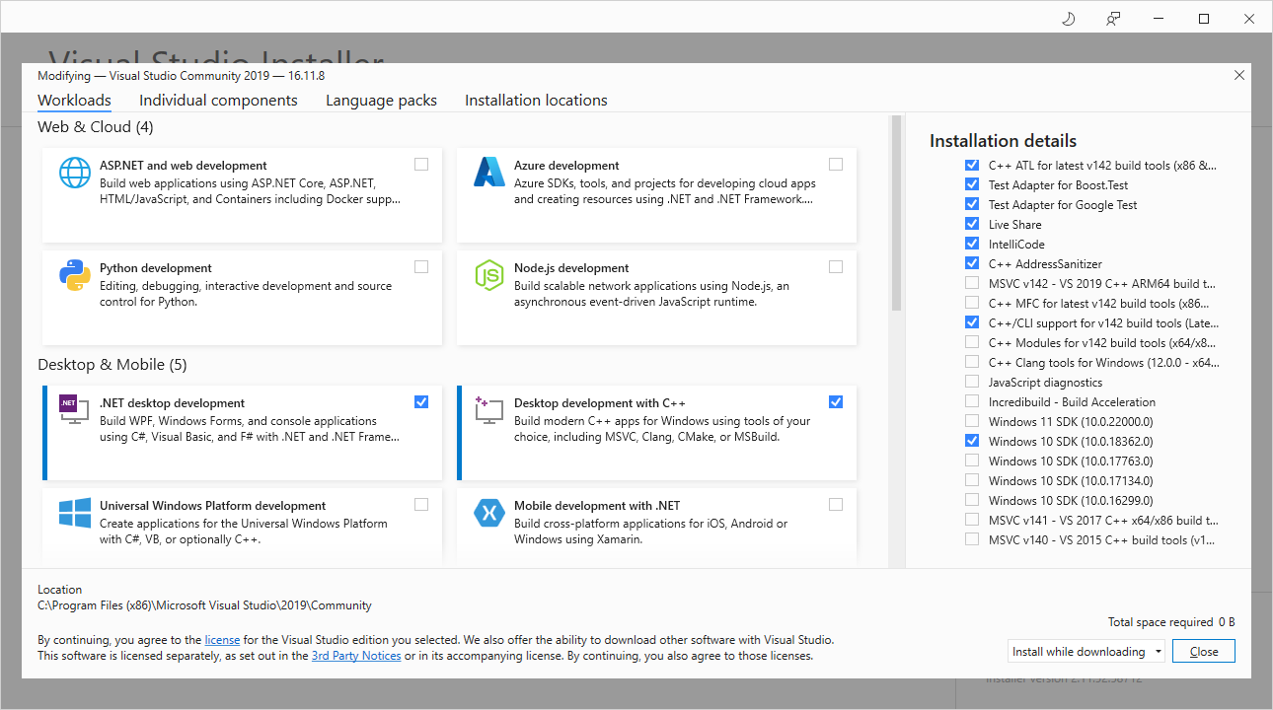

Should say Modify

- Check the box for C++/CLI support for v142 build tools. Check the box for Windows 10 SDK (10.0.1832.0). Leave everything else alone.
- Click Modify. Mine says close, but that is because I have already installed them. It should say modify for you. You will see the Installer screen:
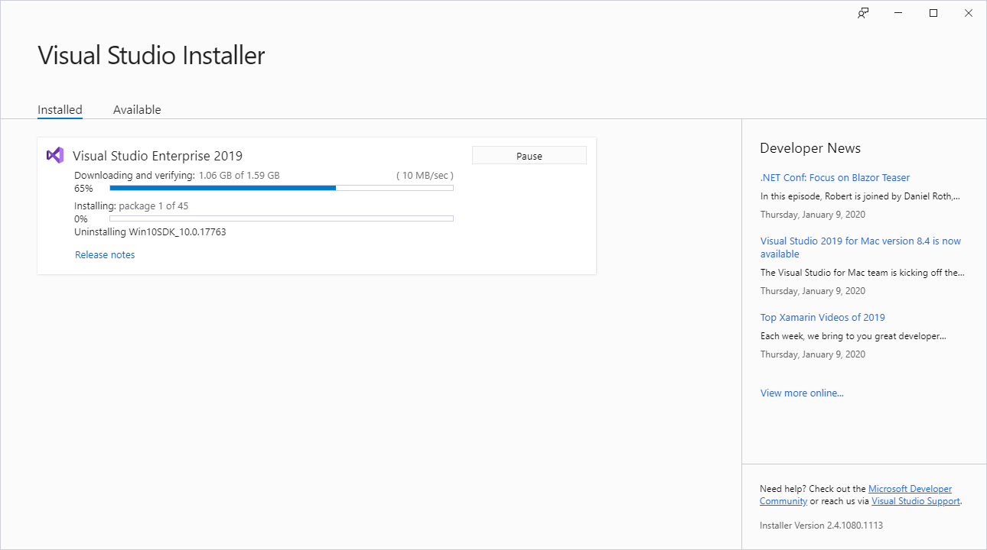

- Enjoy your tea. When the Installer finishes, it will tell you if you need an update. If so, click update. If not, click launch so you can check your version of Visual Studio.
- Create a new project. An Empty Project, as usual. Select Project > Properties > configuration Properties > General.

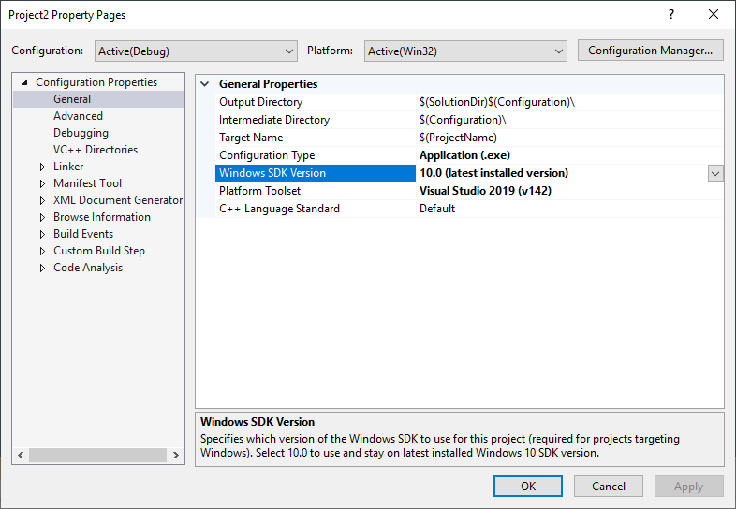

- You should see: under Windows SDK Version : 10.0 (latest installed version).

